|  |
| --- |
| Department of Software Engineering  Mehran University of Engineering and Technology, Jamshoro |

|  |  |  |  |
| --- | --- | --- | --- |
| Course: SWE324 – Distributing Computing | | | |
| Instructor | Rabeea Jaffari | **Practical/Lab No.** | 01 |
| Date | 02 April 2019 | **CLOs** | CLO-4: P3 & P4 |
| Signature |  | **Assessment Score** | 1 Marks |

|  |  |
| --- | --- |
| Topic | To become Familiar with OLTP System Design |
| Objectives | * To Creating applications using Datagram sockets. |

|  |
| --- |
| Lab Discussion: Theoretical concepts and Procedural steps |

|  |
| --- |
| Lab Tasks |
| Submission Date: 09-04-19 |

1. Modify the sample code so that the sender uses the same socket to send the same message to two different receivers. Start the two receivers first, then the sender. Does each receiver receive the message? Capture the code and output. Describe the outcome.

Sender.class

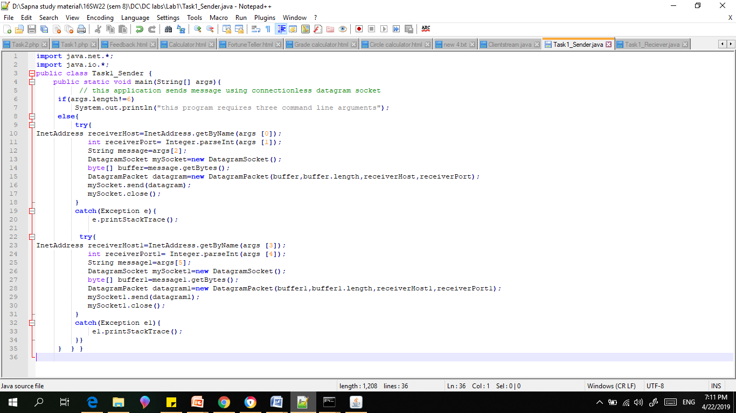

Reciever.java

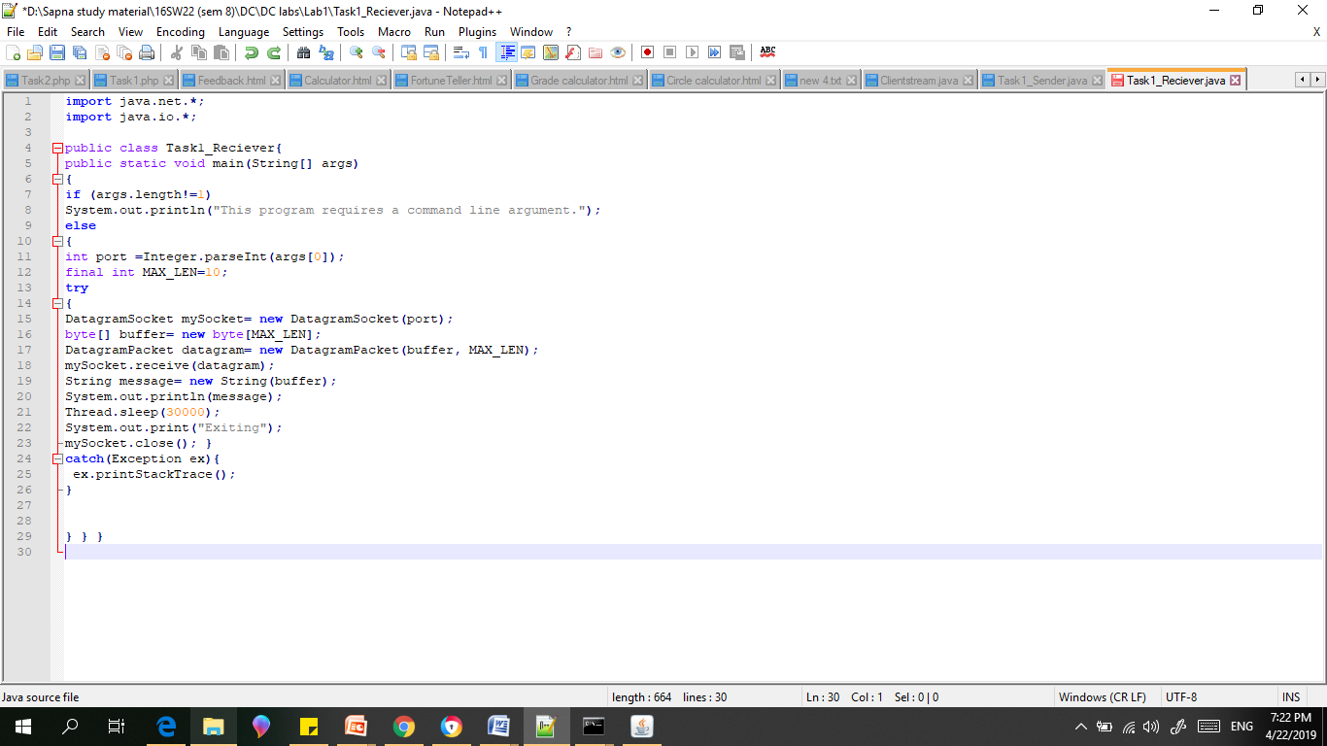

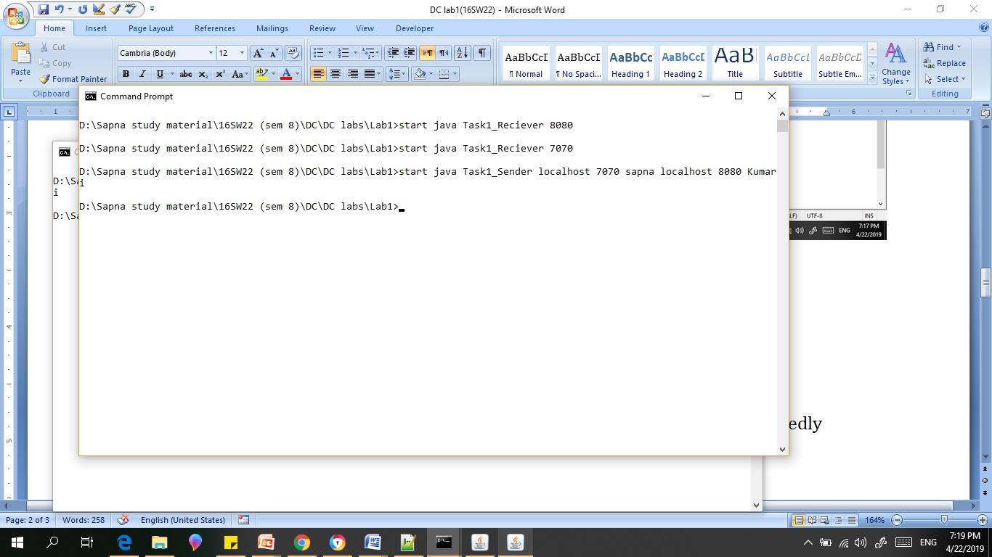

OUTPUT:

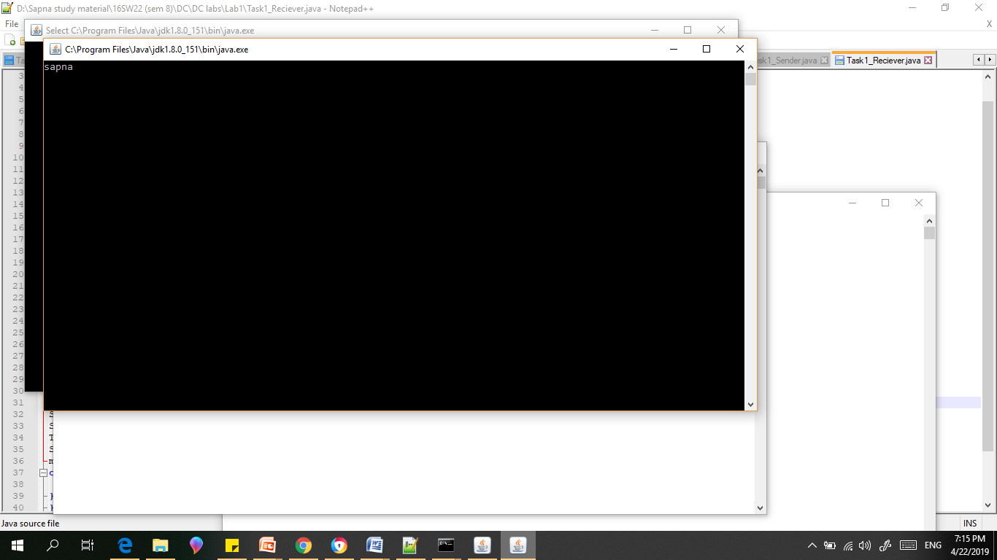

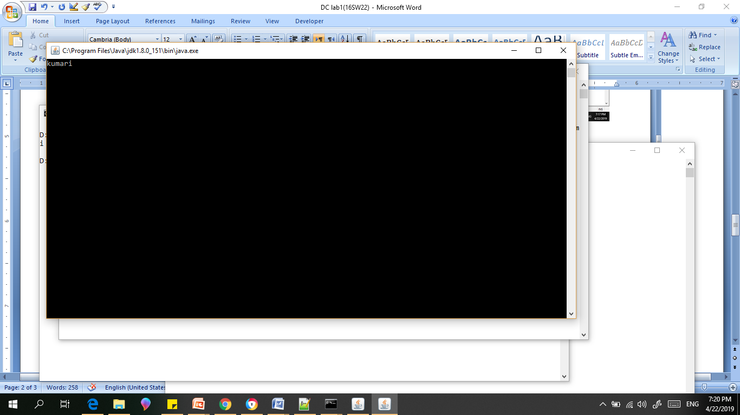

1. Modify the sample code so that the receiver loops five times to repeatedly receive then display your bio data (name, roll num etc.) received. Recompile. Then  
   i. start the receiver  
   ii. Execute the sender, sending your bio data, and  
   iii. In another window, start another instance of the sender, sending your friend’s bio data. Does the receiver receive both the messages? Capture the code and output..

Server.class

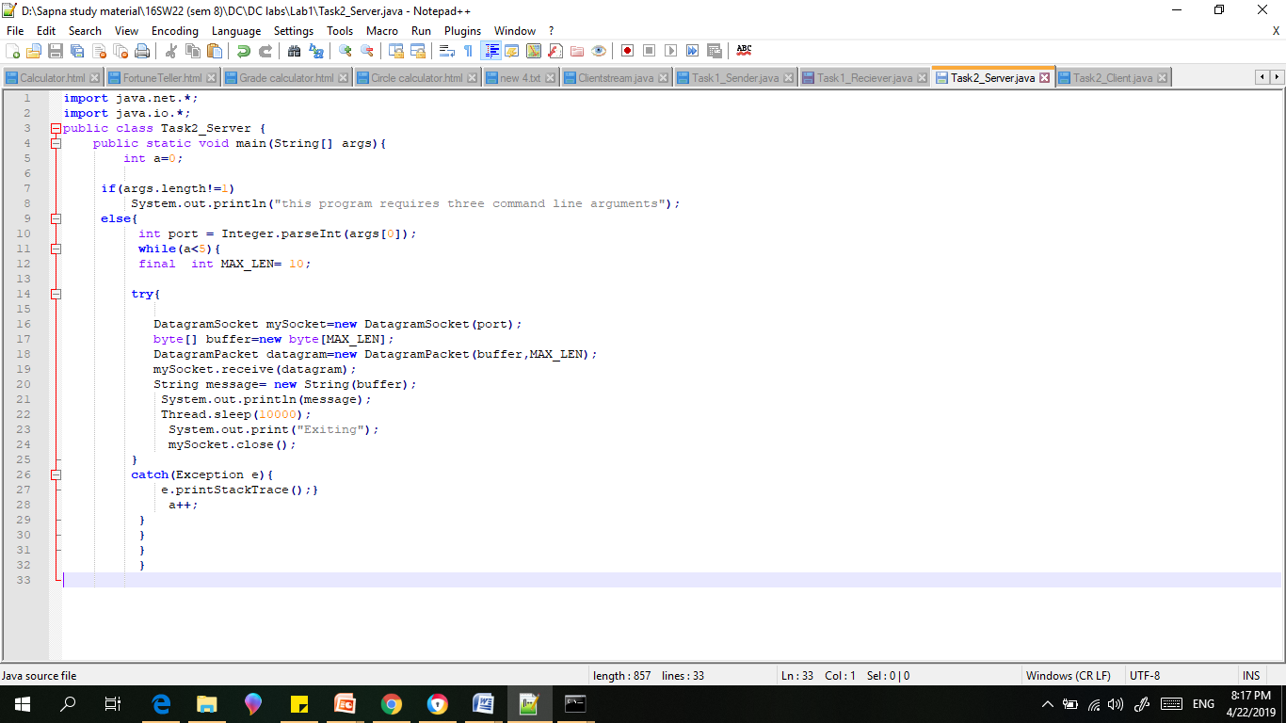

Client.class

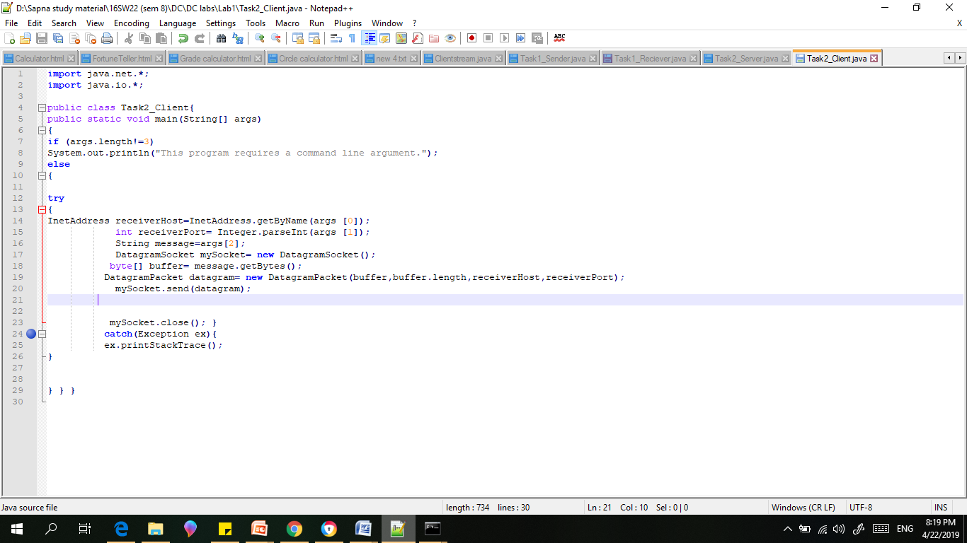

Client1 side

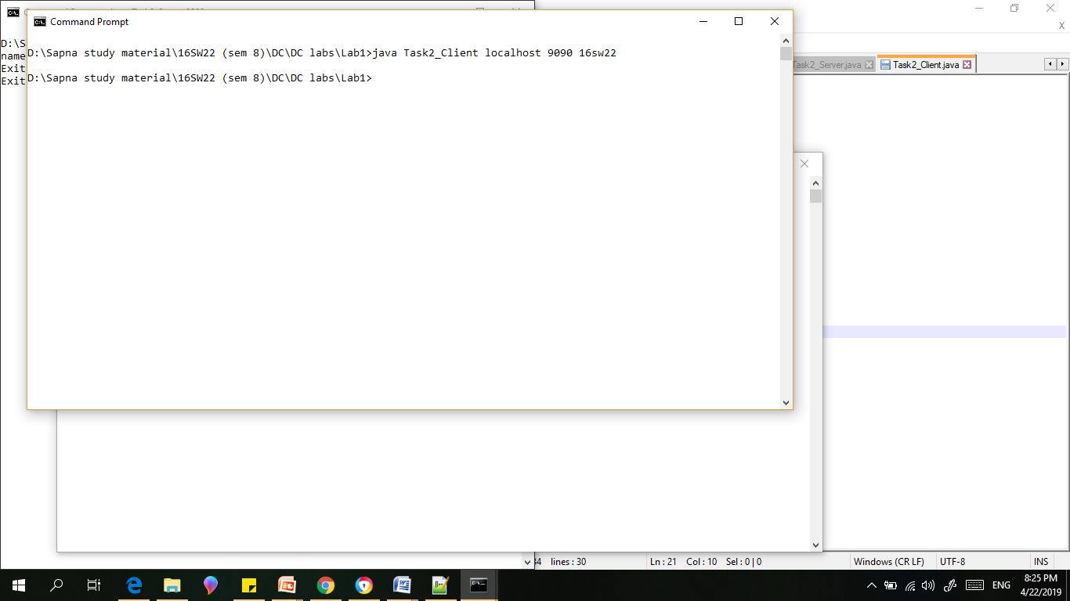

Client 2 side

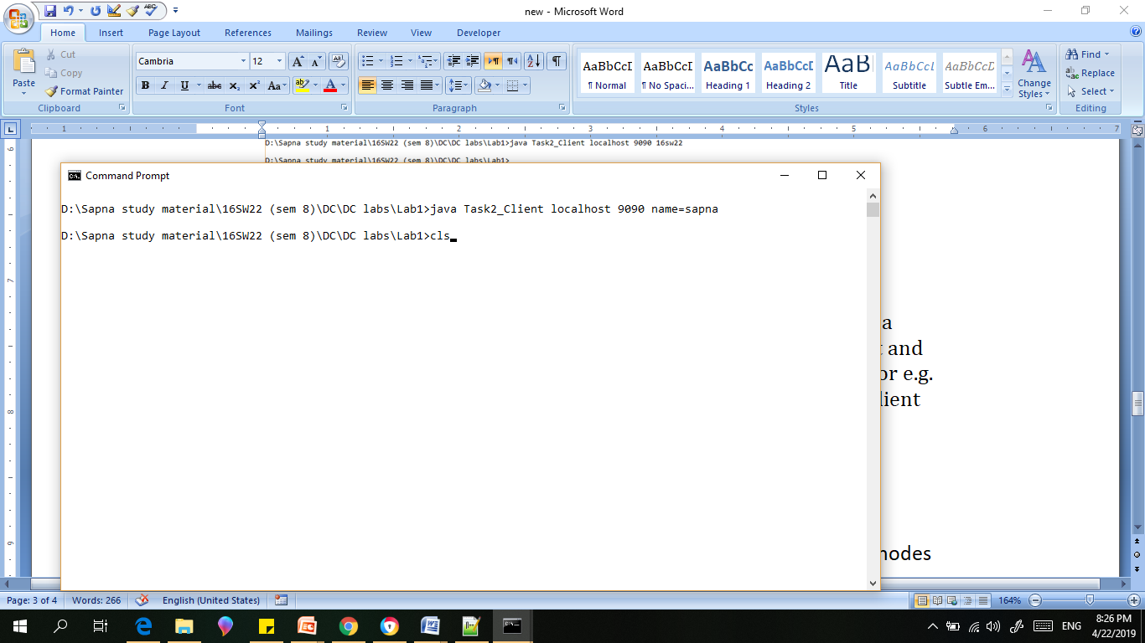

Server

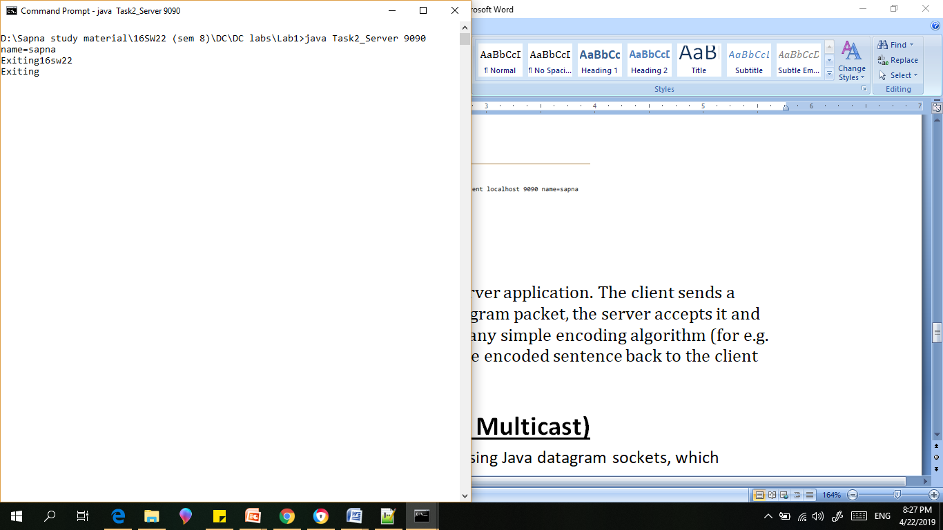

1. Implement an encoding client-server application. The client sends a sentence to the server using datagram packet, the server accepts it and then encodes the sentence using any simple encoding algorithm (for e.g. letters reversal etc.) and sends the encoded sentence back to the client using a datagram packet.
2. revSender.java
3. 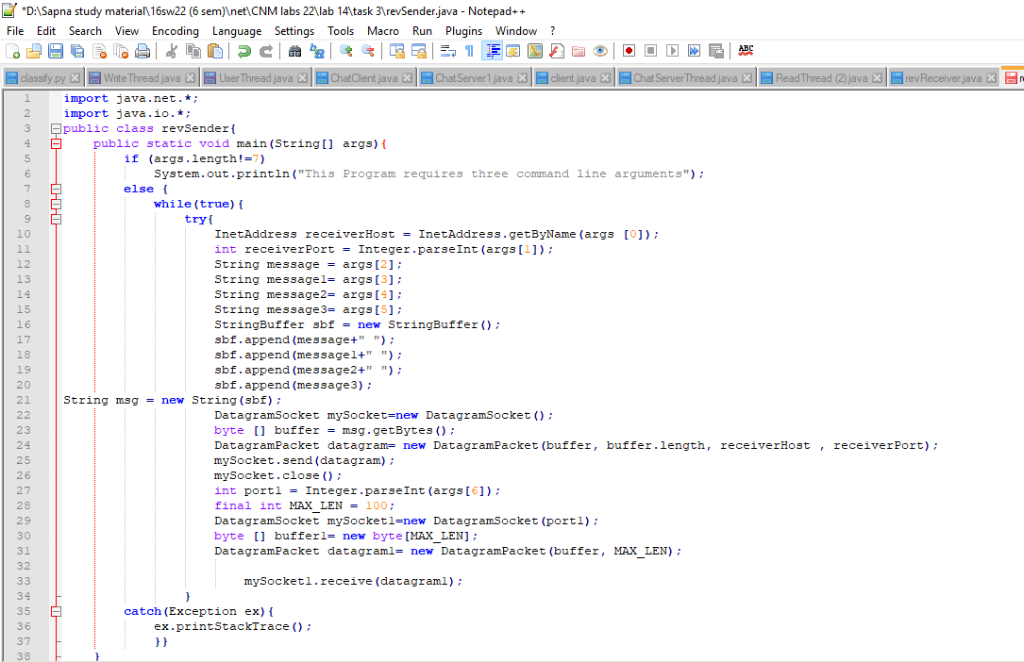
4. revReceiver.java

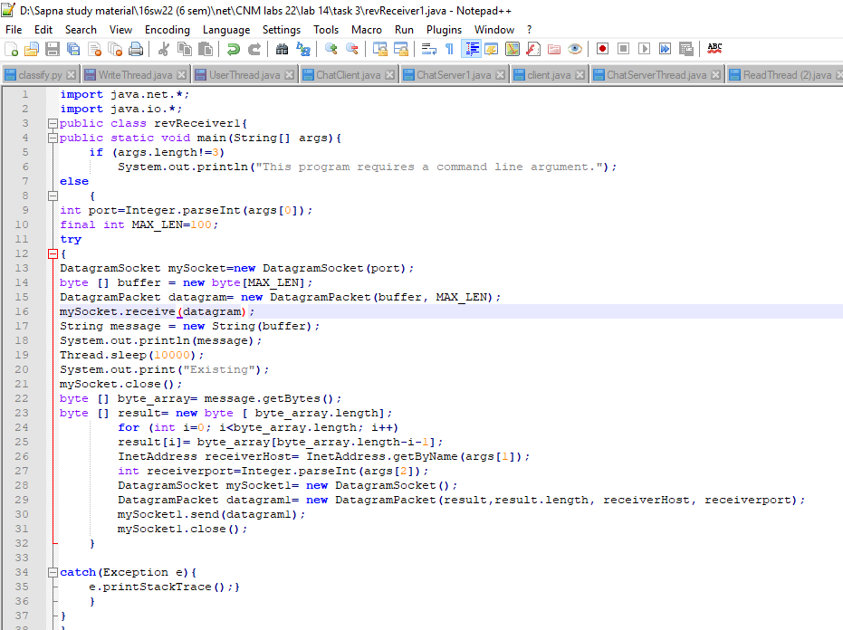

Client output:

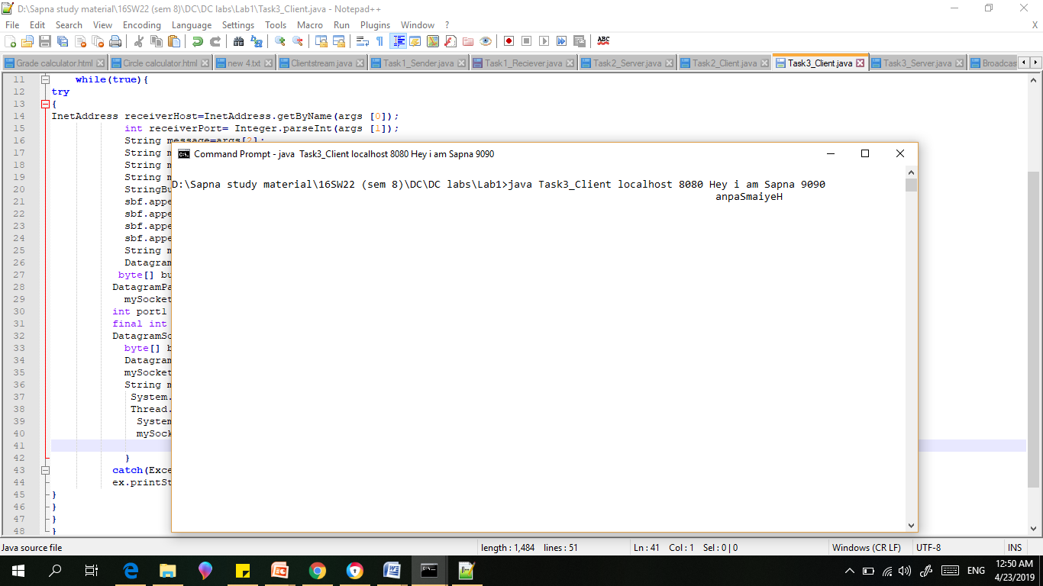

Sender output:

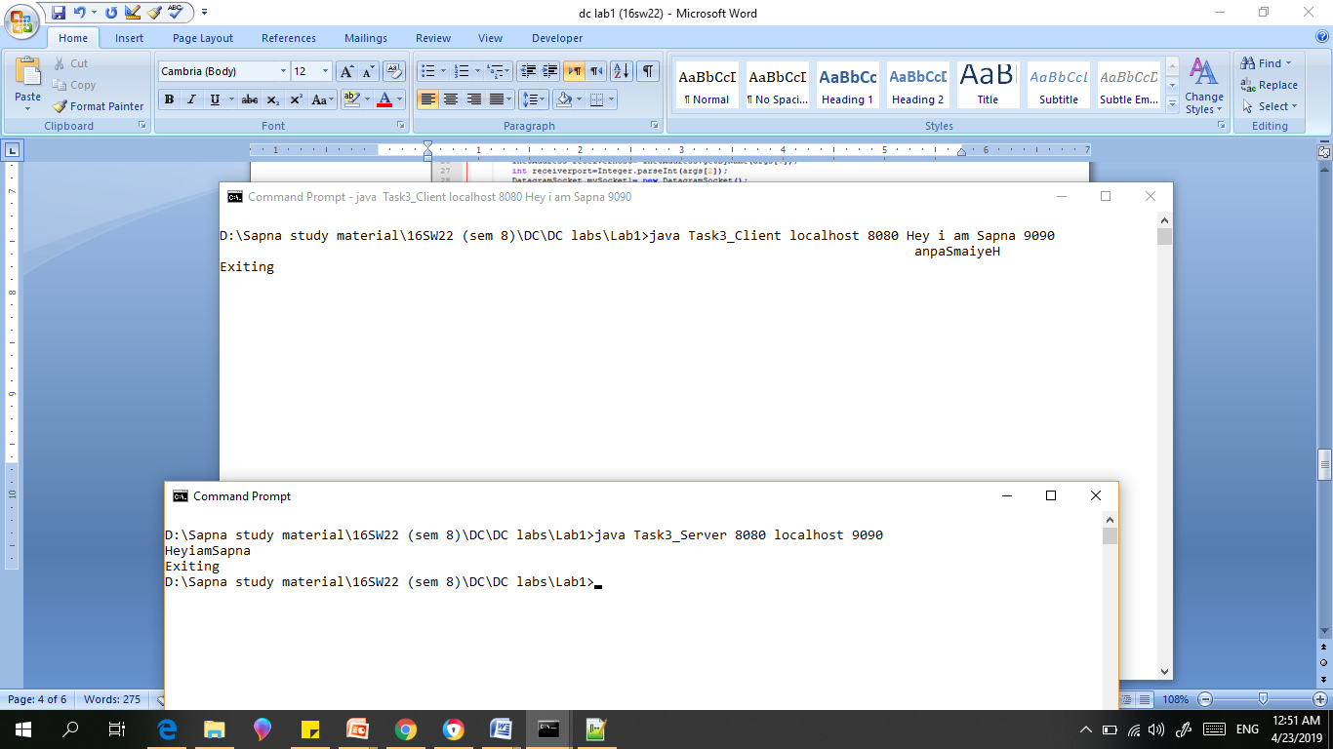

TASK:4 (Broadcast and Multicast).

Implement two simple programs using Java datagram sockets, which broadcasts and multicast your roll number to all or selected network nodes respectively.

1)Broadcast program

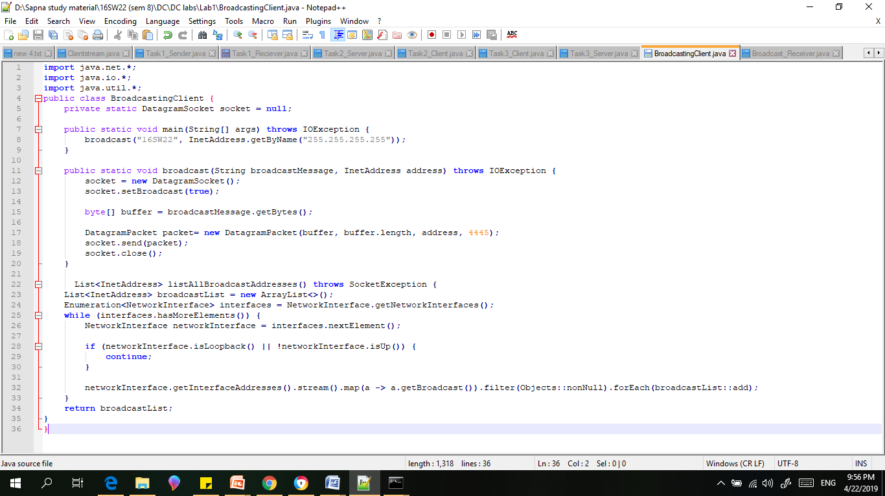

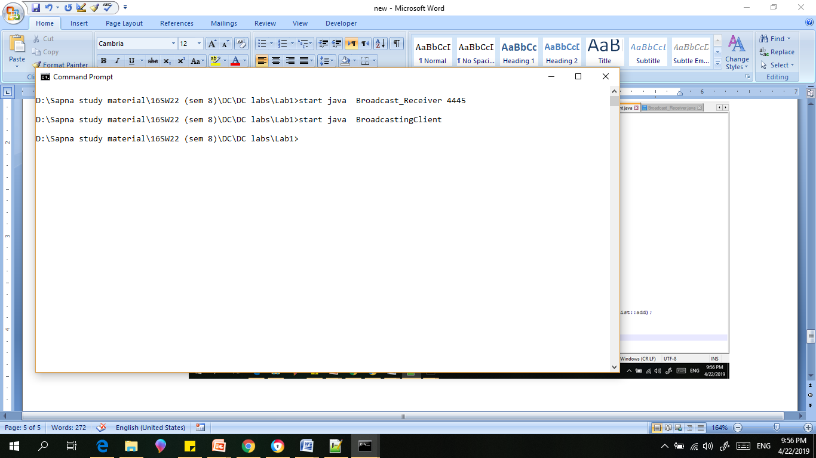

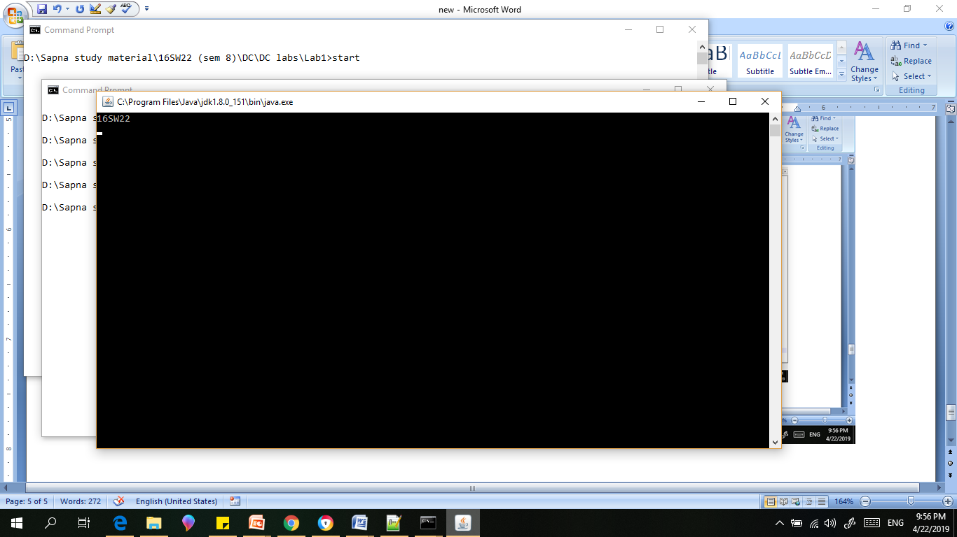

2)Multicast program

Multicasting.java

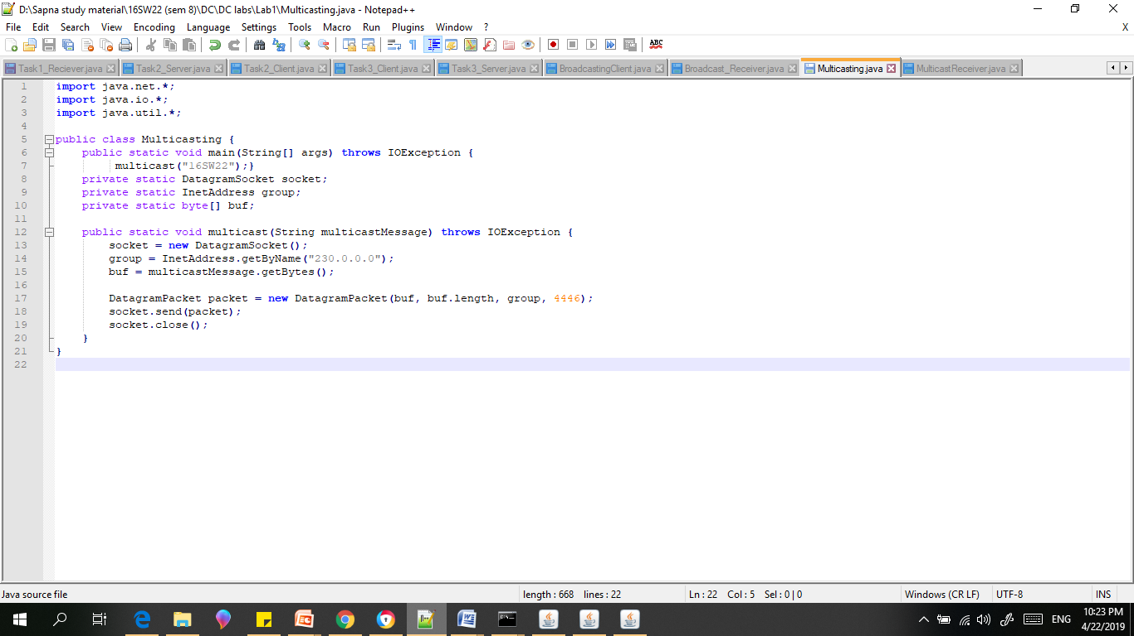

Multicastreciever.java

